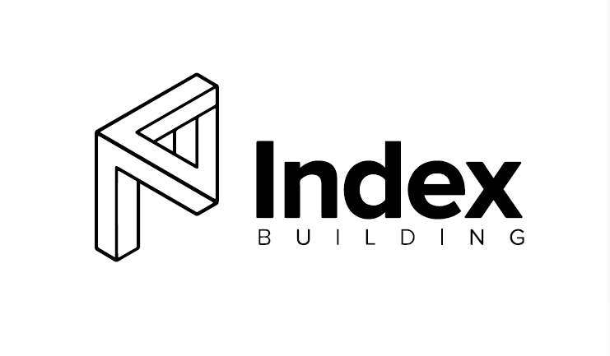

Name of the Company: INDEX BUILDING GROUP PTY LTD

ABN: 83 637 339 372

Address: 12/233 Flemington road, Franklin, ACT 2913

CEO/ Managing Director/ Chairman/

Founder: ZEFENG ZHOU

**Department 3**

Manager

Employee (designation)

Employee (designation)

**Department 1**

Manager: ZEFENG ZHOU

Employee (designation) **Harry Rodgers**

Employee (designation) **Haiyan WANG**

**Department 2**

Manager

Employee (designation)

Employee (designation)

Compliance Manager 1 (FT) Harry RODGERS

HR Officer 1 (FT) Haiyan WANG

Trainee HR Officer 1 (PT) Haiyan WANG

COO/ Senior Manager (PT) ZEFENG ZHOU